Platte City Wide Rummage Sales
Friday, May 31 : 5pm to 8pm
Saturday, June 1 : 8am to 3pm
Registration form due by: Monday, May 27, 2024

Name/s: ___________________________________________________________ Address of Sale (directions if needed): ______________________________________________________________________________________________________________________________________
Dates/Time of Sale if different than above: ___________________________________________________________________
Cell Phone: __________________________________ (not listed on map)
Email Address: ________________________________(not listed on map)
Description of Items for Sale: (Example: baby clothes, plants, household items, etc.) We will modify to fit space, if necessary.
____________________________________________________________________________________________________________________________________________________________________________________________________________________________________________________________________________________________________________
There is a $10 fee to cover administrative/advertising costs.
Checks payable to Platte Area Chamber of Commerce.
Payment methods: Cash, Check payable to Platte Chamber, or PayPal (scan QR Code) and email form to: plattechamber@midstatesd.net.
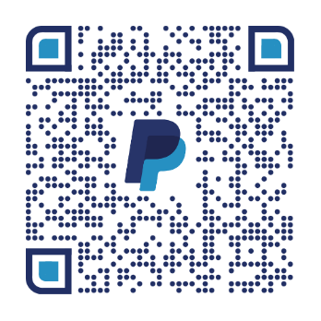Platte Chamber – PO Box 393 – Platte, SD 57369

